Illilouette Basin project log

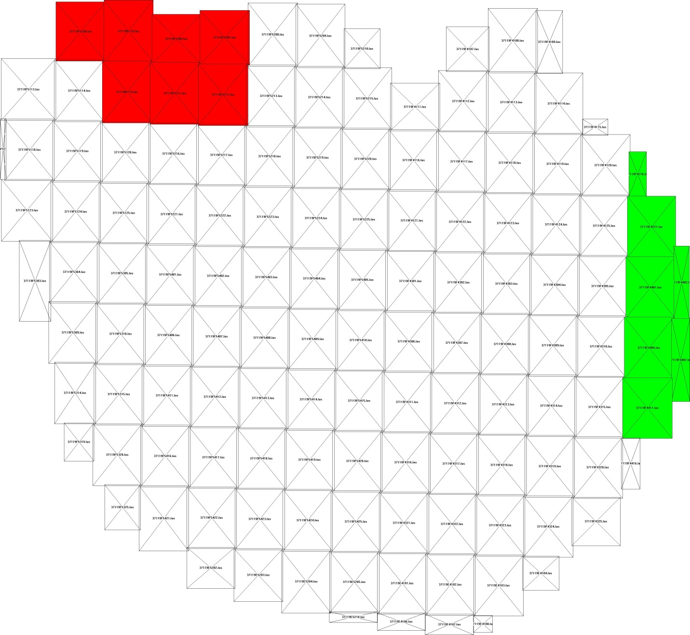

Map of the point cloud (.las) sections.

* Import bare earth layer (dtm for section in question).
  + 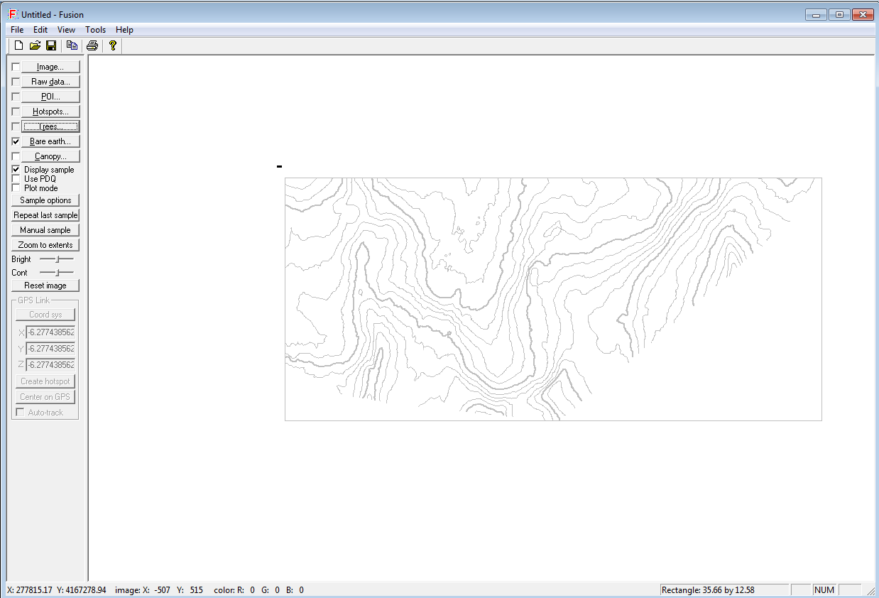
  + This is a bare earth contour map.
* Tools -> Misc -> Create image from Lidar point cloud.
  + Save as tif?
  + Pixel s size is 1m, so cell size can be 3 pixels for output images. Not sure how to standardize pixel value so that it is actual height though.
  + Base values on height; set ground layer as the Bare Earth DTM for the section in question.
* Update: After talking with Van Kane on 12/15/15, it sounds like I don’t want to use the FUSION GUI to do data processing, but rather use the shell interface, as per his tutorial and the steps described on the next page.

2/22/16

Goal: Generate a spatial layer for “percentage of first returns >2m in height”

* Search for cmd.exe and open command prompt
* Launch GridMetrics program (Optional, I think)
  + C:\Users\stevensj>c:\fusion\gridmetrics
* Run GridMetrics using the following syntax

c:\fusion\gridmetrics "C:\Users\stevensj\Documents\Illillouette LiDAR\YNP_Illilouette2011\DTM\BareEarth\be*.dtm" 2 3 "C:\Users\stevensj\Documents\Illillouette LiDAR\YNP_Illilouette2011\jts\Stats\37119E4101.csv" "C:\Users\stevensj\Documents\Illillouette LiDAR\YNP_Illilouette2011\Points\FullCloud\37119E4101.las"

* + The first file path is a composite of all bare earth dtm’s (digital terrain models). The * indicates all files that start with the letters before the * (shell syntax)
  + The 2 indicates the height threshold in m
  + The 3 indicates the cell size in m
  + test.csv indicates the name of the file we’re creating
  + The last file path indicates the stats data file to be written.
  + In the above syntax, it’s important that you use the right font for “ (should be ")
  + You can create a .bat file to run this for multiple .las files, as per: http://www.fs.fed.us/eng/rsac/fusion/pdfs/Exer05PlotStats.pdf (pg 6 of the Fusion Metrics Tutorial)
* Once you have a statistics csv file, you can convert it to a raster GRID for visualization and analysis:

c:\fusion\csv2grid "C:\Users\stevensj\Documents\Illillouette LiDAR\YNP_Illilouette2011\jts\Stats\37119E4101_all_returns_elevation_stats.csv" 49 "C:\Users\stevensj\Documents\Illillouette LiDAR\YNP_Illilouette2011\jts\Raster\Cover_E4101.asc"

* + The first file path is the stats file created in the previous step
  + 49 is the parameter to be assigned a raster value, denotes column 49 in the gridmetrics csv output file. Column 49 correlates to the % cover calculation for each cell or “Percentage first returns above 2.00” (2 m).
  + The last file path indicates the raster file to be written
  + Open and view in ArcMap
    - Note: In the future you will want to define the projec-tion of your lidar derivatives, which will be the same as the raw lidar data. ArcMap does not recognize FUSIONs projection so you have to manually redefine it!

Next step: Develop some batch files to run this protocol for the whole watershed. Should take 2 hrs.

3/21/17

Integrating 2011 canopy layer with 2014 snow data

* Take your %cover raster (% of first returns >2m) from the 2011 point cloud, for a given tile.
* “Snap” this 3m raster to align with the snow layers.
  + Data management -> projections and transformations -> raster -> Project Raster
  + Input the %cover raster, set the output raster to e.g. e4101.tif (specifying tif is important)
  + Output coordinate system: WGS84 UTM 11N
  + Go to Environments -> processing extent -> snap raster, and set to one of the ASO snow rasters. This will snap the output raster, save it as a tif, and put it in the correct projection system all at once.
* Then work with this layer in R to crop the snow layer of interest to this extent, and run stats.

3/22/17

Get DEM

* <https://viewer.nationalmap.gov/basic/?basemap=b1&category=ned,nedsrc&title=3DEP%20View#productSearch>
* Download 1/3 arcsec DEM.
* Project raster to WGS84, using same extent and resolution as one of the ASO snow rasters (including snap raster), as dem.tif